**Excel Assignment - 6**

1. What are the various elements of the Excel interface? Describe how they're used.

The Excel interface consists of various elements that allow users to interact with the spreadsheet software efficiently.

Here are the key elements and their descriptions:

Title Bar:- Located at the top of the Excel window, it displays the name of the current workbook.

we can click and drag it to move the Excel window around the screen.

Ribbon:- The Ribbon is the horizontal toolbar that spans across the top of the Excel window.

It is divided into tabs, each containing groups of related commands. For example, the "Home" tab contains commands for formatting,

copying, and pasting, while the "Insert" tab has options for inserting charts, tables, and more.

Quick Access Toolbar:- This is a small toolbar located above the Ribbon. It provides quick access to commonly used commands.

we can customize it by adding or removing buttons according to our preferences.

File Menu:- In Excel 2010 and older versions, the File menu (referred to as the Office button in Excel 2007) is located at the top-left corner.

In Excel 2013 and newer versions, it is represented by the "File" tab. Clicking on it opens a menu with various file-related options,

such as opening, saving, and printing workbooks.

Worksheet Area:- This is the main working area of Excel where we enter and manipulate data. It consists of a grid of cells,

organized in columns (labeled with letters) and rows (labeled with numbers). The intersection of a column and a row forms a cell.

Formula Bar:- Located just below the Ribbon, the Formula Bar displays the contents of the currently selected cell. It is used to enter or

edit data, as well as to enter formulas and functions.

Name Box:- Situated next to the Formula Bar, the Name Box displays the cell reference of the active cell.

we can use it to navigate quickly to specific cells by entering cell references or named ranges.

Column and Row Headers:- The columns and rows in the worksheet have headers, represented by letters (columns) and numbers (rows).

These headers allow us to identify and reference cells easily.

Sheet Tabs:- At the bottom of the Excel window, we will find sheet tabs, which allow us to switch between different worksheets within the same workbook.

By default, a new workbook starts with three sheets, but we can add or delete sheets as needed.

Status Bar:- Located at the very bottom of the Excel window, the Status Bar provides information about the current state of the worksheet,

such as the sum, average, and count of selected cells, as well as the current status of various functions like Caps Lock and Num Lock.

2. Write down the various applications of Excel in the industry.

Finance and Accounting: Excel is extensively used in finance and accounting for tasks like budgeting, financial analysis,

expense tracking, financial modeling, and creating financial statements such as income statements, balance sheets, and cash flow statements.

Business Analysis: Excel is a go-to tool for business analysts to analyze data, identify trends, and make data-driven decisions.

It helps in creating dashboards, generating reports, conducting market research, and performing various business forecasting tasks.

Human Resources: HR professionals use Excel for managing employee data, calculating payroll, tracking attendance, analyzing workforce trends,

and creating performance reports.

Sales and Marketing: Excel is utilized by sales and marketing teams for lead tracking, managing customer data, analyzing sales performance,

creating marketing budgets, and conducting sales forecasts.

Project Management: Project managers rely on Excel for creating project timelines, Gantt charts, resource allocation sheets, and tracking project progress.

Inventory Management: Excel is employed to maintain inventory records, track stock levels, reorder points, and manage supply chain logistics.

Data Analysis and Reporting: Excel's data analysis capabilities, such as pivot tables, charts, and data filters,

are widely used to analyze large datasets and generate insightful reports.

Engineering and Manufacturing: Engineers and manufacturers use Excel for calculations, data organization, inventory control, and creating production schedules.

Education and Research: Excel is commonly used in academic settings for data analysis, statistical calculations, grading, and organizing research data.

Real Estate and Property Management: Excel helps real estate professionals manage property listings, calculate mortgage payments,

analyze rental income, and track property expenses.

Healthcare: In healthcare, Excel is used for patient data management, medical expense tracking, and analyzing healthcare outcomes.

Logistics and Supply Chain: Excel aids in tracking shipments, managing logistics data, and optimizing supply chain operations.

Non-profit Organizations: Excel is valuable for budgeting, donor management, and generating financial reports for non-profit organizations.

Small Business Management: Excel is widely used by small business owners for financial planning, inventory control, and sales tracking.

Data Visualization and Dashboards: Excel is used to create interactive and visually appealing dashboards that summarize complex data for quick insights.

3. On the ribbon, make a new tab. Add some different groups, insert commands in the groups and name them according to their commands

added. Copy and paste the screenshot of the steps you followed.

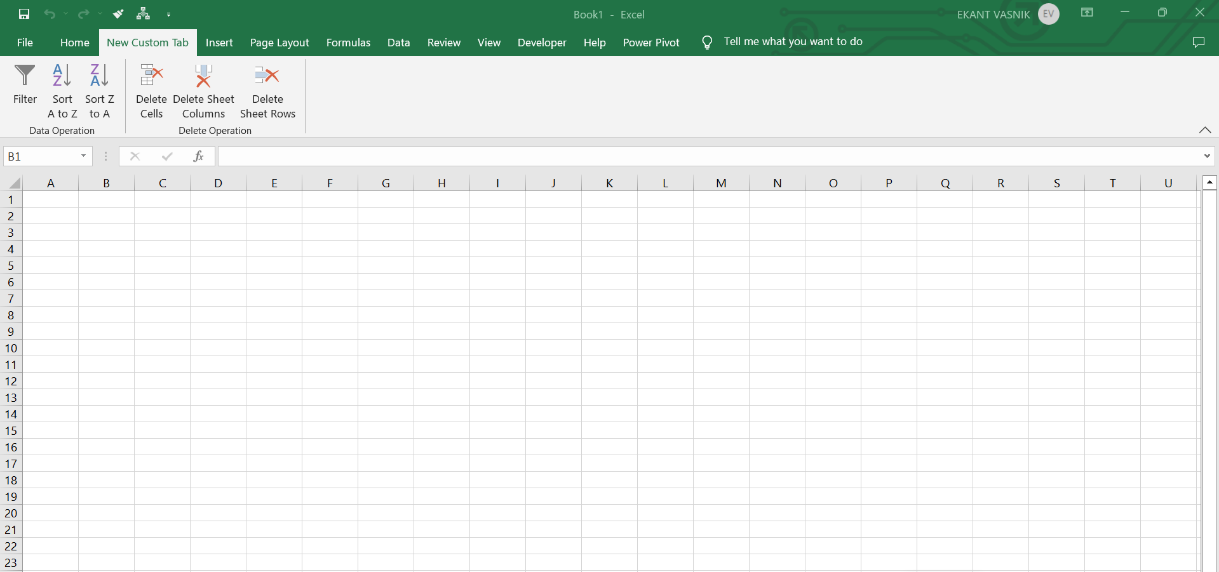

4. Make a list of different shortcut keys that are only connected to

formatting with their functions.

Here is a list of different shortcut keys in Microsoft Excel that are specifically connected to formatting:

Ctrl + B: Bold - Applies or removes bold formatting to the selected text or cell contents.

Ctrl + I: Italic - Applies or removes italic formatting to the selected text or cell contents.

Ctrl + U: Underline - Applies or removes underline formatting to the selected text or cell contents.

Ctrl + 1: Format Cells - Opens the "Format Cells" dialog box, allowing we to change various formatting options.

**Ctrl + Shift + &: Apply Border - Adds a thin border around the selected cells.

**Ctrl + Shift + _: Remove Border - Removes the border from the selected cells.

Ctrl + Shift + ~: General Number Format - Applies the "General" number format to the selected cells.

Ctrl + Shift + $: Currency Format - Applies the "Currency" number format to the selected cells.

Ctrl + Shift + %: Percentage Format - Applies the "Percentage" number format to the selected cells.

Ctrl + Shift + !: Comma Format - Applies the "Comma" number format to the selected cells.

Ctrl + Shift + #: Date Format - Applies the "Date" number format to the selected cells.

Ctrl + Shift + @: Time Format - Applies the "Time" number format to the selected cells.

Ctrl + Shift + ^: Scientific Notation Format - Applies the "Scientific" number format to the selected cells.

**Ctrl + Shift + **: Exponential Notation Format - Applies the "Exponential" number format to the selected cells.

**Ctrl + Shift + &: Outline Border - Displays the "Outline Border" toolbar for additional border formatting options.

Ctrl + 5: Strikethrough - Applies or removes strikethrough formatting to the selected text or cell contents.

Ctrl + Shift + F: Font Dialog Box - Opens the "Font" dialog box for advanced font formatting options.

Ctrl + Shift + P: Point Size - Increases the font size of the selected text.

Ctrl + Shift + M: Decrease Font Size - Decreases the font size of the selected text.

Ctrl + E: Center Align - Centers the selected text or cell contents horizontally.

5. What distinguishes Excel from other analytical tools?

Excel distinguishes itself from other analytical tools in several ways, making it a unique and popular choice for data analysis and manipulation.

Here are some key characteristics that set Excel apart:

User-Friendly Interface: Excel has a user-friendly and familiar spreadsheet interface that makes it accessible to a wide range of users,

including those without extensive technical knowledge. Its grid-based layout and easy-to-use functions simplify data entry, calculations, and analysis.

Widespread Availability: Excel is widely available and pre-installed on most Windows-based computers, making it easily accessible to a large

number of users without the need for additional software purchases or installations.

Versatility: Excel is highly versatile and can handle a wide range of tasks, from basic data entry and calculations to complex data analysis,

financial modeling, and charting. It serves as an all-in-one solution for various analytical needs.

Formula and Function Capabilities: Excel's extensive library of formulas and functions allows users to perform complex calculations and

manipulate data efficiently. It includes mathematical, statistical, financial, and logical functions, among others.

Data Visualization: Excel provides various chart types and visualization tools that enable users to create visually appealing

charts and graphs to present data in a comprehensible manner.

Ease of Learning: Excel is relatively easy to learn, especially for those familiar with basic spreadsheet concepts.

Users can quickly grasp fundamental functionalities and progressively explore more advanced features as needed.

Interactivity: Excel allows users to create interactive spreadsheets with features like data validation, drop-down lists,

and conditional formatting, enhancing the usability and user experience.

Integration with Other Microsoft Products: Excel seamlessly integrates with other Microsoft Office applications, such as

Word and PowerPoint, making it convenient to import and export data between different tools.

Macro and VBA Support: Excel supports Visual Basic for Applications (VBA), which allows users to create custom macros and automate

repetitive tasks, significantly improving efficiency and productivity.

Small to Medium-sized Data Sets: Excel is well-suited for handling small to medium-sized data sets.

While it may struggle with large datasets that require more complex data processing, it remains an excellent choice for everyday data analysis.

6. Create a table and add a custom header and footer to your table.

